

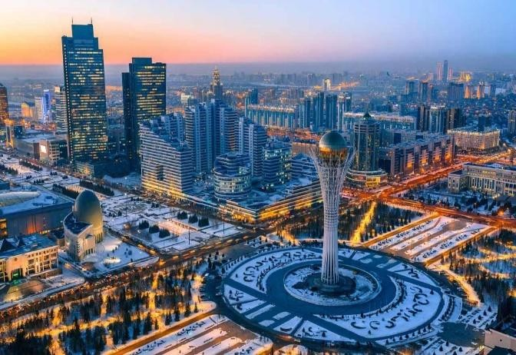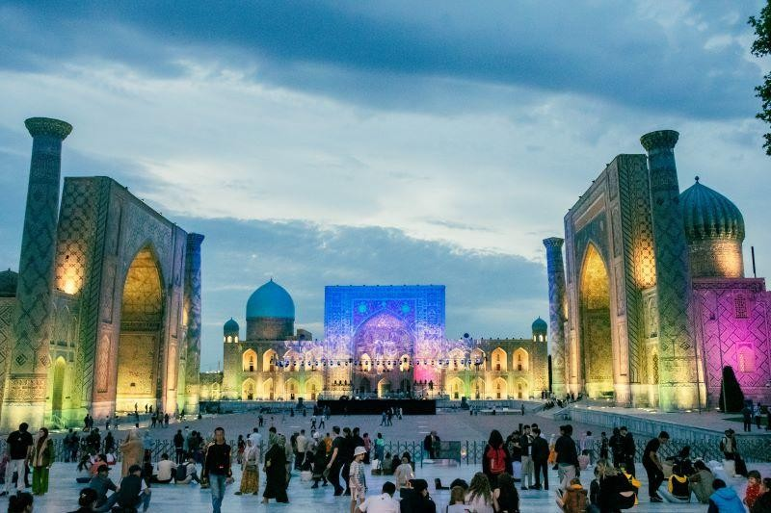
11 NIGHTS 12 DAYS KAZAKHASTHAN UZBEKISTHAN & AZERBAIJAN TOUR

DAYWISE ITINENARY

Day 1(01 JUN) – ARRIVED ALMATY - Arrival in Almaty International Airport. Complete airport formalities. Transfers to the Hotel. Guaranteed Early check in from 31st May. Breakfast at hotel. Post Breakfast you will proceed for Almaty City tour, Green Bazar, Kok Tobe Gondola Ride. Dinner at restaurant. Overnight at Almaty hotel.(L,D)

Day 2(02 JUN) – ALMATY SIGHTSEEING -Breakfast at hotel. Today you will proceed for Charyn Canyon & Kolsai Lake for full day. Return to Almaty. Dinner at restaurant. Overnight at Almaty hotel. (D)
Day 3(03 JUN) - ALMATY SIGHTSEEING -Breakfast at hotel. Today you will proceed for Day trip to Shymbulak Ski resort and enjoy Level 3 via Gondola Ride. Lunch and Dinner at restaurant.
Overnight at Almaty Hotel. (L,D)

Day 4( 04 JUN) – ALMATY TO TASHKENT -Packed Breakfast. Check-out. Depart to Almaty airport for your flight to Uzbekistan. Arrival in Tashkent airport & Transfer to the Hotel. Dinner at restaurant. Overnight at Tashkent hotel (D)
Day 5(05 JUN) - TASHKENT SIGHTSEEING - Breakfast at hotel. Today you will visit Tashkent City Tour for full day. Lunch and Dinner at restaurant. Overnight at Tashkent Hotel. (L,D)

Day 6(06 JUN) – TASHKENT – SAMARKAND - Breakfast at hotel. Check-out, Transfer to Tashkent Railway station, Take the fast Train and Arrival in Samarkand. Visit Samarkand Day tour & later Check-in to the Samarkand Hotel. Lunch and Dinner at restaurant. Overnight at Samarkand Hotel. (L,D)
Day 7(07 JUN) – SAMARKAND SIGHTSEEING - Breakfast at hotel. Today you will cover Samarkand tour with Paper Mill. Dinner at restaurant. Overnight at Samarkand Hotel. (D)

Day 8(08 JUN ) - SAMARKAND – X/TASHKENT – BAKU - Packed breakfast. Check-out, Depart to Railway station board the train for Tashkent. Arrival in, Transfer to the Tashkent airport. Board your flight to Baku Azerbaijan. Arrival in Baku airport & Transfer to the Hotel & Baku City tour with Funicular Ride. Overnight at Baku Hotel. (L,D)

Day 9(09 JUN) – BAKU SIGHTSEEING - Breakfast at hotel. Later visit Absheron - Gobustan Day trip with fire temple and burning mountain and Lada Car for Mud Volcano. Lunch and Dinner at restaurant. Overnight at Baku Hotel. (L,D)
Day 10(10 JUN) - BAKU – GABALA – Breakfast at hotel. Check-out, Baku to Gabala, Explore Nohur Lake Boat Ride on the way & Gabala 2-line Cable Car & Check-in to the Gabala Hotel. Lunch and Dinner at restaurant. Overnight Gabala Hotel. (L,D)

Day 11(11 JUN) – GABALA – X/BAKU DEPRTURE - Breakfast at hotel. Check out by 12noon, Transfer Gabala to Baku, Baku tour along with Shopping Time and Proceed for the airport 3 hours before flight time, Enroute Dinner at restaurant. Flight will depart from Baku Airport after midnight. (D)

HOTEL DETAILS
HOTEL | CITY | ROOM TYPE | CHECK IN | CHECK OUT
KAZZHOL ALMATY OR SIMILAR | Almaty | STD ROOM | 31 MAY | 04 JUN
CONSTI TASHKENT HOTEL OR SIMILAR | Tashkent | STD ROOM | 04 JUN | 06 JUN
SAMARIA HOTEL  SAMARKAND OR SIMILAR | Samarkand | STD ROOM | 06 JUN | 08 JUN
QAFQAZ BAKU HOTEL OR SIMILAR | Baku | STD ROOM | 08 JUN | 10 JUN
GABALA GARDEN OR SIMILAR | Gabala | STD ROOM | 10 JUN | 11 JUN

- INCLUSION:
- 11 nights’ Accommodation at the above-mentioned Hotels or Similar.
- Guaranteed Early check in on arrival at Almaty Hotel.(from 31st May ).
- Airfare (from Ex Kolkata).
- Uzbekistan E Visa.
- Azerbaijan E Visa.
- Insurance Up to 60 Yrs.
- Sightseeing as per the above itinerary.
- Entry ticket (wherever it applicable).
- Major Meals Specified in the above itinerary (11 Breakfast, 07 Lunch, 11 Dinner).
- AC coach service during the tour and return transfer.
- Train travel within Uzbekistan (Tashkent – Samarkand – Tashkent) by Bullet Train.
- English speaking Local guide tour during sightseeing.
- 02 Bottle of 500 ML water per person per day.

EXCLUSION:
- Any Expenses of a Personal Nature
- Early check-in & Late check-out.
- Any meal or snack you have at other restaurant other than specified above will be chargeable
- Beverage Orders
- Late night adult show
- Shore Excursions
- Exercise Classes and Personal Trainer
- Dining Entertainment
- Photography
- Baby Sitting Services
- Art purchases
- Video Arcade
- Wi/Fi & Satellite connection for tablets, phones/mobile devices
- Use of the Medical Centre
- Massage Centre, Beauty Salon
- Game Rental / KTV Rooms / Conference Facilities
- Glow Bowl
- Casino and Gambling Activities
- Duty-free shopping

- Internet Access
- Specialty Onboard Seminars
- Gift shop purchases
- Calls off the ship
- Laundry Services
- Any additional credit card and fuel surcharges; and taxes on the provision of additional services, including services that are not provided by Resort World Cruises.
- Before 7 am and after 10 pm 50 % extra surcharges are applied
- Meals Other than Mentioned Above
COSTING

ROOMING | COST COMPONENT INR PP | TOTAL COST PER PERSON
DOUBLE SHARING | Airfare + Visa + Insurance – Rs 1,12,700/- Land Service USD 1400/- | 2,45,000/- PP
NOTE:
- 1 USD = INR 94.50

- USD ARE DYNAMIC ( XE + INR 2.5 USD).

- PREVELING RATES IS APPLICABLE

- 5% TCS & 5% GST APPLICABLE IN GROSS BILLING

IMPORTANT NOTE:

- Please note that this is a tentative standard itinerary, and the prices may vary at the time of booking if the group size falls.
- It’s a group package based on 20 Guests travelling together.
- Rates are subject to change during long weekends, festive season, holidays, or due to exchange rate fluctuations.
- No booking is made as of now. Cruise Cabins are subject to availability at the time of booking and will be at prevailing rate. The rates given above are the best promotional rates available as of now.
- Flight fares are dynamic and can change at any time.
- Hotels are subject to availability at the time of booking

- Cost is based on 3 pax and is subject to change if the group size increases or decreases.
- Check in time 1400/Check out 1200.
- Transportation does not include transfers for dinner or any other meal or any other sight other than mentioned in the itinerary
- Surcharges and supplements maybe applicable during certain periods.
- Date can be Change any time without prior notice for operational reason.
- All Rights reserved by Kolkata Holidays only.

